Mrs. Stephanie & Mrs. Freedom’s Newsletter
February 16, 2024
What’s happening in our room?
What a great Valentine ’s Day they had! This week my groups were retelling Moonbear’s shadow. We discussed character, setting and the problem in the story. Mrs. Freedom’s group tracing shaped for form a new picture.
What’s coming up?
2/19 President’s Day
2/26 Dr. Seuss Week (schedule on back
3/1 Dr. Seuss’ Birthday

Need me?
sconnally@tcjackets.net , Seesaw or 229-225-3908
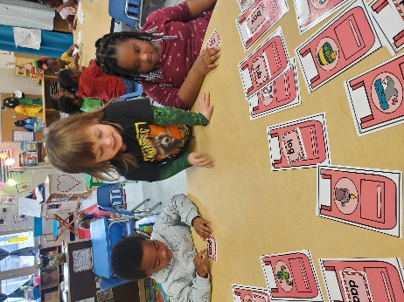
Kazi, Alex & Keasley reading CVC words.

